COPY FILES

cp /home/data/sql.challenges/roster/bbclean.csv /home/2020/summer/jy1045/sql.challenges
cp /home/data/sql.challenges/roster/engagement-data.csv /home/2020/summer/jy1045/sql.challenges
cp /home/data/sql.challenges/roster/student_roster.csv /home/2020/summer/jy1045/sql.challenges
cp /home/data/sql.challenges/roster/p8p10.data /home/2020/summer/jy1045/sql.challenges

Pq00.txt

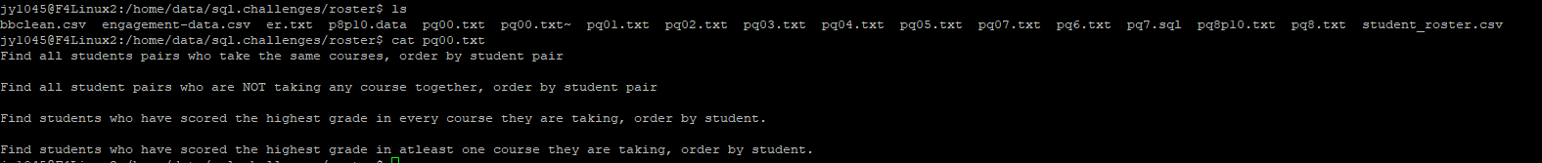

SELECT * FROM studentroster;

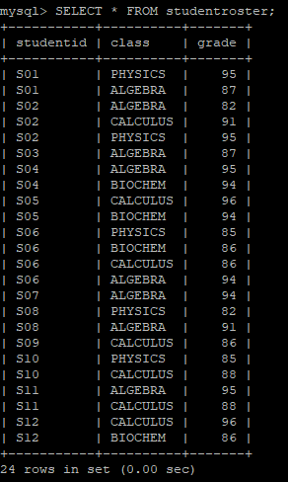

/* select database */
use jy1045;

/* Find all students pairs who take the same courses, order by student pair */
SELECT DISTINCT a.studentid, b.studentid FROM studentroster as a
JOIN studentroster AS b ON a.studentid < b.studentid AND a.class = b.class
ORDER BY a.studentid, b.studentid;

/* Find all student pairs who are NOT taking any course together, order by student pair */
SELECT DISTINCT a.studentid, b.studentid FROM studentroster as a
JOIN studentroster AS b ON a.studentid < b.studentid
AND (a.studentid, b.studentid) NOT IN
(SELECT a2.studentid, b2.studentid FROM studentroster AS a2
JOIN studentroster AS b2 On
a2.studentid < b2.studentid AND a2.class = b2.class)
ORDER BY a.studentid, b.studentid;

/* Find students who have scored the highest grade in every course they are taking, order by student. */
SELECT a.studentid FROM
(SELECT studentid, count(c.studentid) AS counta
FROM studentroster AS c
JOIN
(SELECT class, max(grade) AS maxgrade FROM studentroster
GROUP BY class) AS d
ON c.class=d.class AND c.grade=d.maxgrade
GROUP BY c.studentid) AS a
JOIN
(SELECT studentid, COUNT(studentid) as countb
FROM studentroster
GROUP BY studentid) AS b
ON a.studentid = b.studentid AND a.counta = b.countb
ORDER BY a.studentid;

/* Find students who have scored the highest grade in at least one course they are taking, order by student */
SELECT DISTINCT c.studentid FROM studentroster AS c
JOIN
(SELECT class, max(grade) AS maxgrade FROM studentroster
GROUP BY class) AS d
ON c.class=d.class AND c.grade=d.maxgrade;

Pq01.txt



/* select database */
USE jy1045;
DROP table IF EXISTS bbclean;

/* load the data into bbclean.csv into table. */
CREATE TABLE IF NOT EXISTS bbclean (
student VARCHAR(255) NOT NULL,
classid VARCHAR(255) NOT NULL
);

LOAD DATA LOCAL INFILE 'bbclean.csv'
INTO TABLE bbclean
FIELDS TERMINATED BY ','
LINES TERMINATED BY '\n';
SELECT * FROM bbclean;

/* after loading create a second table which has three columns (separating name and email) */
ALTER TABLE bbclean CHANGE student name VARCHAR(255);
ALTER TABLE bbclean ADD COLUMN email VARCHAR(255) AFTER name;
UPDATE bbclean SET email= SUBSTRING_INDEX(SUBSTRING_INDEX(name,'[',-1),']',1);
UPDATE bbclean SET name= SUBSTRING_INDEX( name, '[', 1 );
SELECT * FROM bbclean;

Pq02.txt


/* list number of students in each class producing ouptput like class, #ofstudents */
SELECT classid AS class, count(email) AS num_of_students FROM bbclean
GROUP BY classid;

Pq03.txt
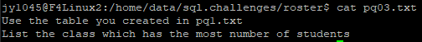

/* List the class which has the most number of students */
SELECT a.class FROM
(SELECT classid AS class, count(email) AS num_of_students
FROM bbclean
GROUP BY classid) AS a
JOIN
(SELECT max(num_of_students) AS num_of_students
FROM (SELECT classid AS class, count(email)
AS num_of_students
FROM bbclean
GROUP BY classid)
AS b) AS c
ON c.num_of_students = a.num_of_students;

Pq04.txt
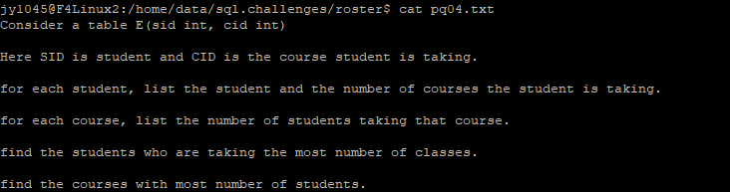

Pq05.txt


Pq6.txt
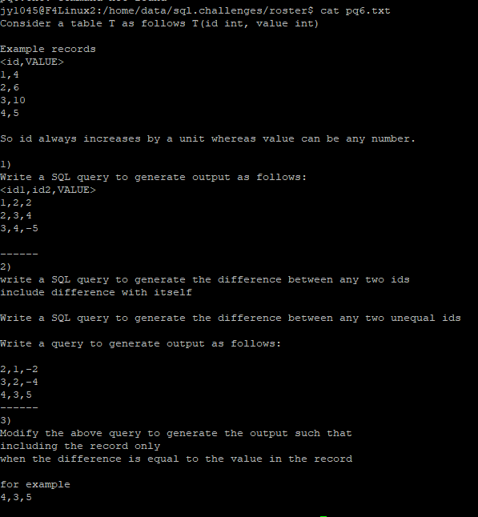

Pq8.txt
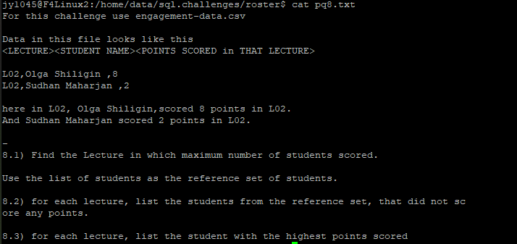

Pq8p10.txt
